Deerwalk Institute of Technology
Sifal, Kathmandu

Simulation and Modelling Practical

Submitted By: Submitted To:
Name: Sagar Giri Binod Sitaula
Roll No: 205
Section: A

Date:

Background Theory

Kolmogorov-Smirnov Test

This test compares the continuous cdf (cumulative distribution function) F(x) of the uniform distribution, with the empirical cdf, sn(xi) for the sample of N random numbers.
The largest absolute derivation between F(x) and Sn(x) is determined and is compared with the critical, value which is available as function of N in the KS-table for various level of confidence.

At first, we generate random numbers using Linear Congruential method and test the uniformity of the generated random numbers using KS-Test.

Background theory for Linear Congruential method:
It is the most commonly used technique for generating random numbers and was initially purposed by
Lehmer in 1951. This technique provides a sequence of integer between 0 and 1 by following recursive
relation:
for i=0,1,2,.....
where Xo = Seed
a = multiplier
c = increment
m = modulus

If c≠0, then the method is called mixed congruential method, else it is called multiplicative Congruential method.

Algorithm for KS-Test:
- Rank the data from smallest to largest. If R(i) denotes the ith smallest observation, R(i)<R(2)<R(3)<.....R(N).
- Compute:
D+ =

D- =

- Compute: D = max of (D+, D-)
- Determine the critical value D(alpha) from KS table for the specified level of significance and given sample size N.
- If D > D(alpha), null hypothesis is rejected else null hypothesis is accepted which says that the data is uniformly distributed.

Program Coding:
#include <stdio.h>
#include <math.h>
#define MAX_NO 500
int main()
{
//linear congruental method to generate random numbers:
int a,m,c=0,i,x,j,flag=0,N=0, choice;
float rand[MAX_NO], temp;
printf("Mixed (1) or Multiplicative (2)?\n");
scanf("%d",&choice);
if(choice == 1)
{
printf("Enter the value of c: ");
scanf("%d",&c);
}
printf("Enter the value of x0, a & m\n");
scanf("%d%d%d",&x,&a,&m);
while(1) {
rand[i] = (float)x/m;

for(j=0;j<=i;j++) {
if(i==j) {
continue;
}
else if(rand[i] == rand[j]) {
flag = 1;
break;
}
else{
flag = 0;
}
}
x = (a*x+c)%m;
N++; i++;
if(flag ==1){
break;
}
}
printf("\nno of randoms generated= %d",N);

//Rank the random numbers in increasing order
for(i=0;i<N;i++){
for(j=0;j<N-i-1;j++){
if(rand[j]>rand[j+1]){
temp=rand[j];
rand[j]=rand[j+1];
rand[j+1]=temp;
}
}
}

//Display the random numbers
printf("\n");
for(i=0;i<N;i++){
printf("%f ",rand[i]);
}

//BEGIN OF K-S test
//setup the hypothesis
printf("\n\nHypothesis\n");
printf("H0 : Numbers are uniformally distributed\n");
printf("H1 : Numbers are not uniformally distributed\n");

float tempX[MAX_NO], tempY[MAX_NO];
float Dpo, Dne, D, Dalpha;

for(i = 0;i<N;i++){
tempX[i] = (float)(i/N) - rand[i];
tempY[i] = rand[i] - (float)((i-1)/N);
}
Dpo = tempX[0];
for (i = 0; i<10; i++){
if (tempX[i]>Dpo){
Dpo = tempX[i];
}
}
Dne = tempY[0];
for (i = 0; i<10; i++){
if (tempY[i]>Dne){
Dne = tempX[i];
}
}

//Find the actual value of D
D = (Dpo > Dne ? Dpo: Dne);

printf("\nEnter critical value at 0.05 level of significance from table: ");
scanf("%f",&Dalpha);

printf("\n\n\t\tConclusion\t\t\n");
printf("\n\n");

printf("D-calculated=%.4f and D-tabulated=%.4f",D,Dalpha);
printf("\n\n");

if(D<=Dalpha){
printf("D-calculated <= D-tabulated. \nNull Hypothesis H0 is accepted and numbers are uniformally distributed.\n");
}
else{
printf("D-calculated > D-tabulated.\nNull Hypothesis H0 is rejected and numbers are not uniformally distributed.\n");
}
return 0;
}

Output:
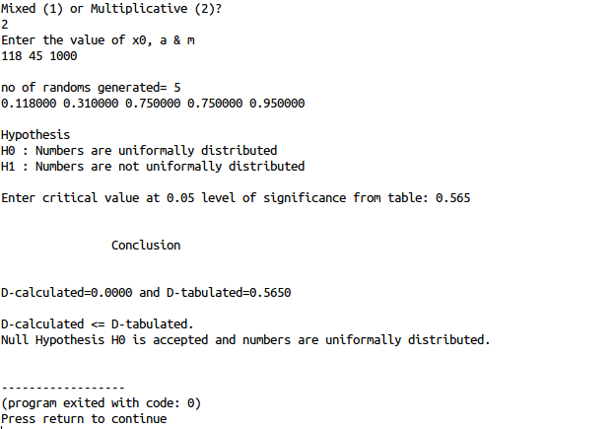

Conclusion:

Hence, 5 random numbers were generated using linear congruential method and Kolmogorov Smirnov test was done which verified the uniform distribution of the random numbers.

